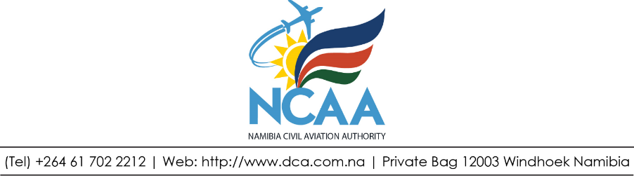

DANGEROUS GOODS INVESTIGATION REPORTS REGISTER

File # and Report # | Date | Person involved | Dangerous Goods Involved | Shipper | Consignee | Operator/ Handling Agent | Violation | Remarks | Closure  Date Inspector

